Pf lab 5 all task

TASK 1:
#include<stdio.h>

int main(){
int a , b;
float result;
printf("enter furst number: ");
scanf("%i" , &a);
printf("entr second number: ");
scanf("%i" , &b);
result = a + b * (a-b)/2;
printf("answer: %f\n" , result);
printf("step 1: remove brckets\n");
printf("step 2: divide the result by 2\n");
printf("step 3: multiply the result with b\n");
printf("step 4:add a to the result");

}
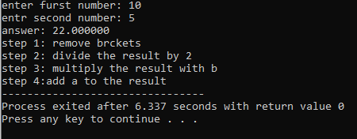

TASK 2:
#include<stdio.h>

int main(){
int x,y;
printf("enter first number: \n");
scanf("%i" , &x);
printf("enter second number: \n");
scanf("%i" , &y);
printf("(x>5) && (y<10) = %d\n" , (x>5) && (y<10));
printf("(x==10) || (y==5) = %d\n" , (x==10) || (y==10));
printf("!(x==y) = %d\n" , !(x==y));

}

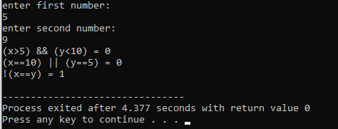

TASK3:
#include<stdio.h>
#include <math.h>

int main(){
int num;
float result;
printf("enter your number: ");
scanf("%d" , &num);
result = sqrt ( num );
printf("result: %.2f" , result);
}
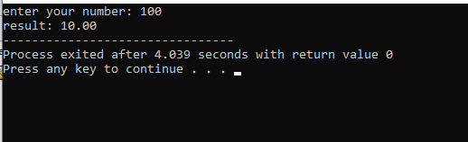

TASK4:
#include<stdio.h>
main(){

int m , n;
printf("enter the value for m: \n");
scanf("%i" ,&m);
printf("enter value for n: \n");
scanf("%i" , &n);
(m>n) ? printf("%i is greater thn %i" , m , n) : printf("%i is greater than %i" , n , m);

}
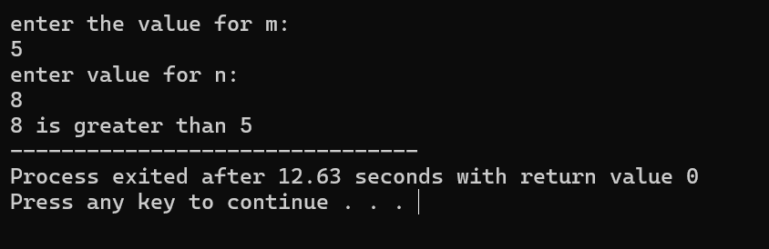

Task 5:
#include <stdio.h>

int main() {
int course;
char grade;

printf("Enter course number (1, 2, or 3): ");
scanf("%d", &course);

switch (course) {
case 1:
case 2:
case 3:
printf("Enter grade (A, B, C, D, F): ");
scanf(" %c", &grade);

switch (grade) {
case 'A':
printf("Excellent performance in Course %d\n", course);
break;
case 'B':
printf("Good performance in Course %d\n", course);
break;
case 'C':
printf("Average performance in Course %d\n", course);
break;
case 'D':
printf("Below average performance in Course %d\n", course);
break;
case 'F':
printf("Failed in Course %d\n", course);
break;
default:
printf("Invalid grade entered.\n");
break;
}
break;

default:
printf("Invalid course number entered.\n");
break;
}

return 0;
}
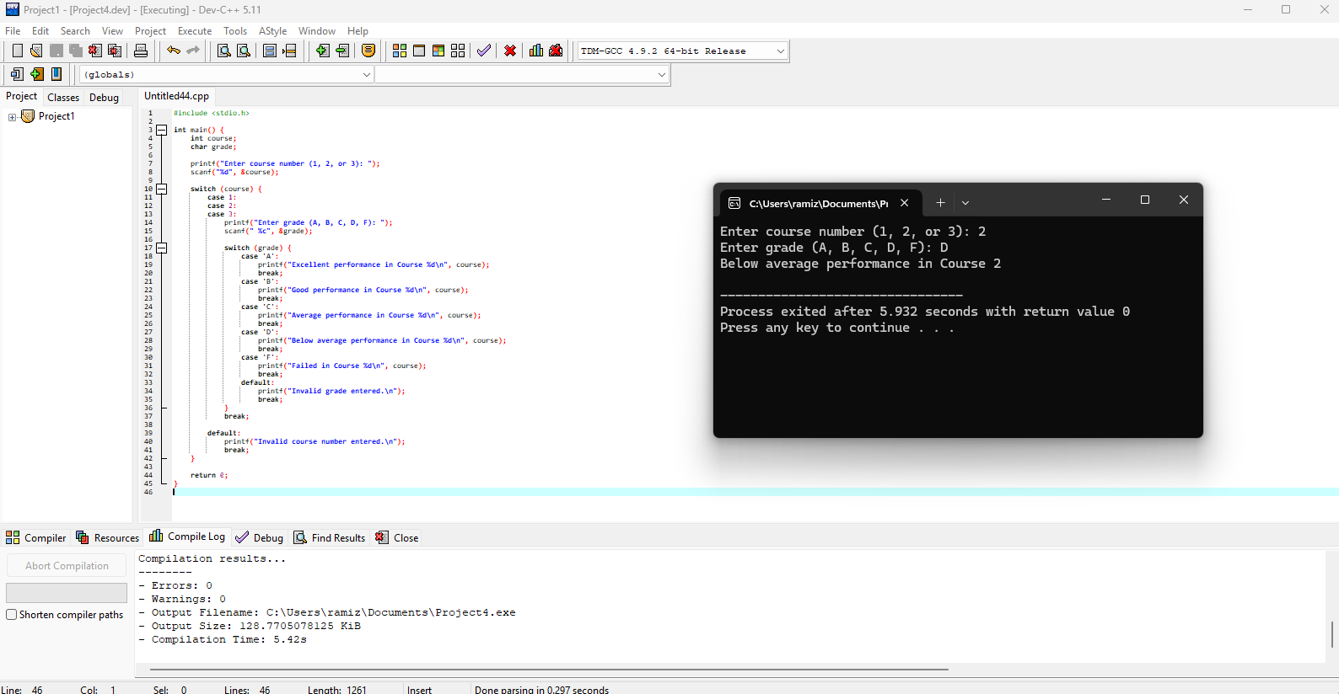

Task 6
#include <stdio.h>

int main() {
int x, y, z, max;

printf("Enter three numbers: ");
scanf("%d %d %d", &x, &y, &z);

max = (x > y) ? ((x > z) ? x : z) : ((y > z) ? y : z);

printf("The largest number is: %d\n", max);

return 0;
}
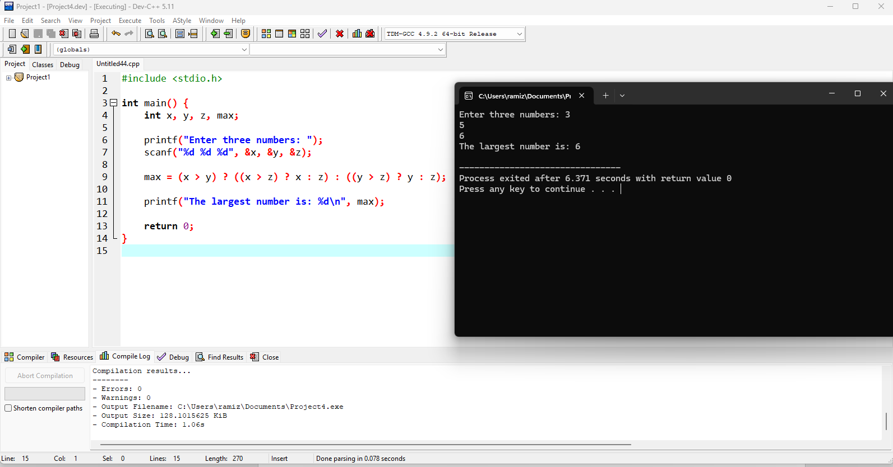

Task7
#include <stdio.h>

int main() {
int a, b;

printf("Enter two integers: ");
scanf("%d %d", &a, &b);

printf("Sum: %d\n", a + b);
printf("Difference: %d\n", a - b);
printf("Product: %d\n", a * b);

if (b != 0) {
printf("Quotient: %d\n", a / b);
printf("Remainder: %d\n", a % b);
} else {
printf("Division by zero is not allowed.\n");
}

return 0;
}
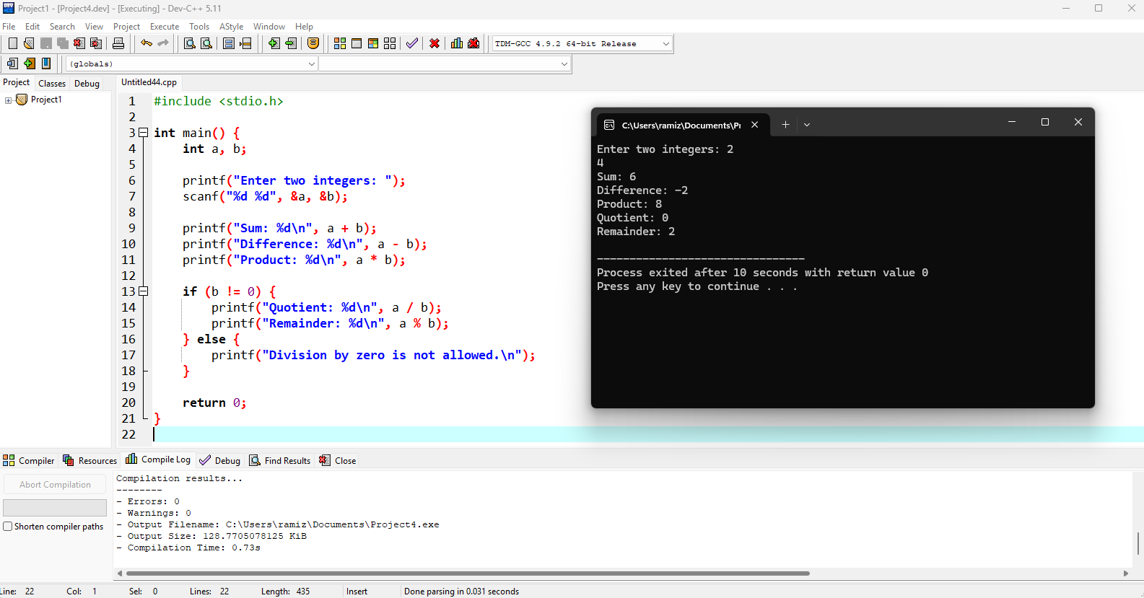

Task 8
#include <stdio.h>

int main() {
int a, b;

printf("Enter two integers: ");
scanf("%d %d", &a, &b);

printf("a == b: %d\n", a == b);
printf("a > b: %d\n", a > b);
printf("a < b: %d\n", a < b);
printf("a != b: %d\n", a != b);
printf("a >= b: %d\n", a >= b);
printf("a <= b: %d\n", a <= b);

return 0;
}

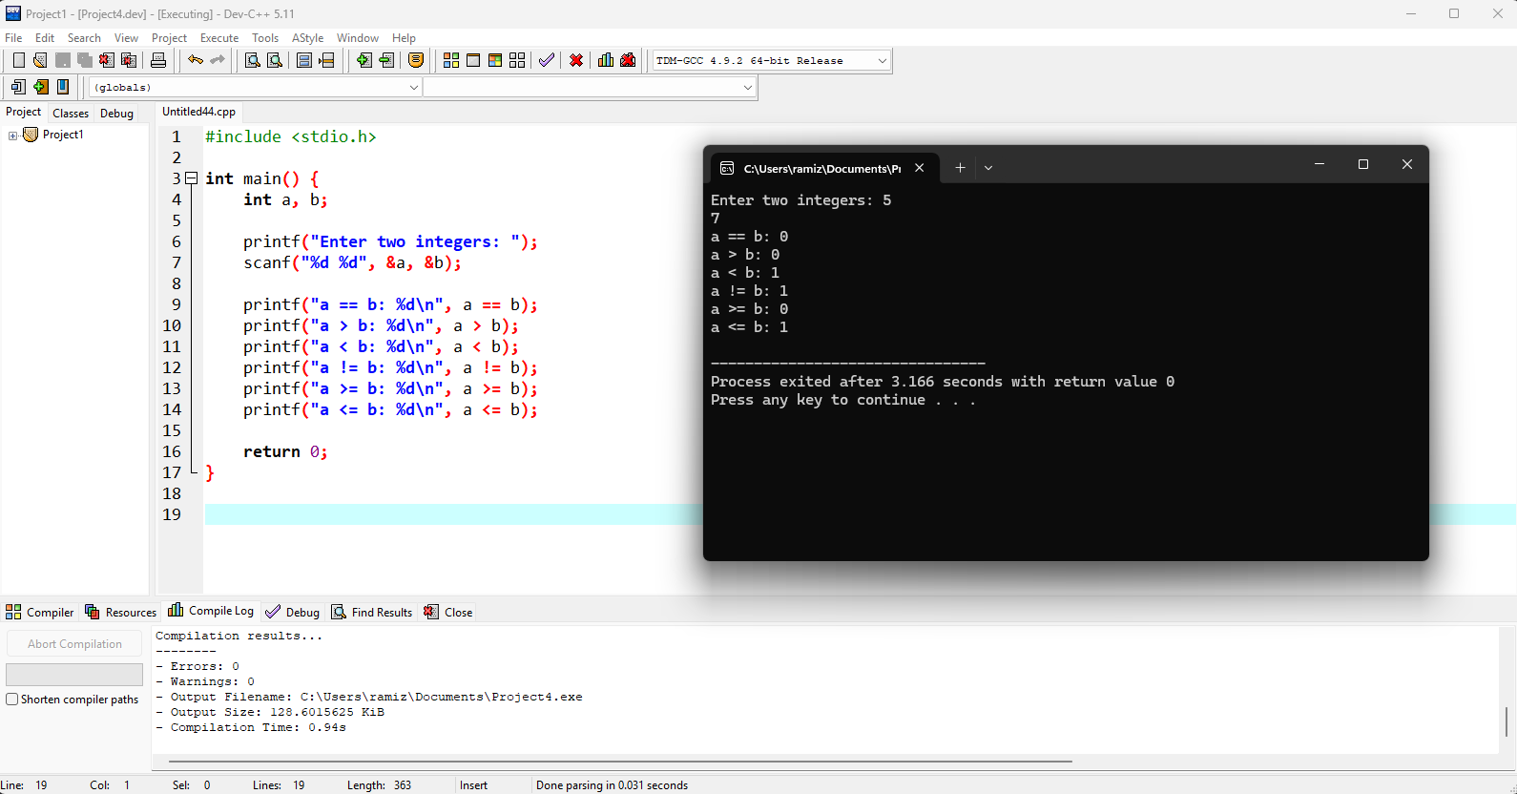

Task 9
#include <stdio.h>

int main() {
int a, b;

printf("Enter two integers: ");
scanf("%d %d", &a, &b);

printf("a & b: %d\n", a & b);
printf("a | b: %d\n", a | b);
printf("a ^ b: %d\n", a ^ b);
printf("~a: %d\n", ~a);
printf("a << 1: %d\n", a << 1);
printf("a >> 1: %d\n", a >> 1);

return 0;
}
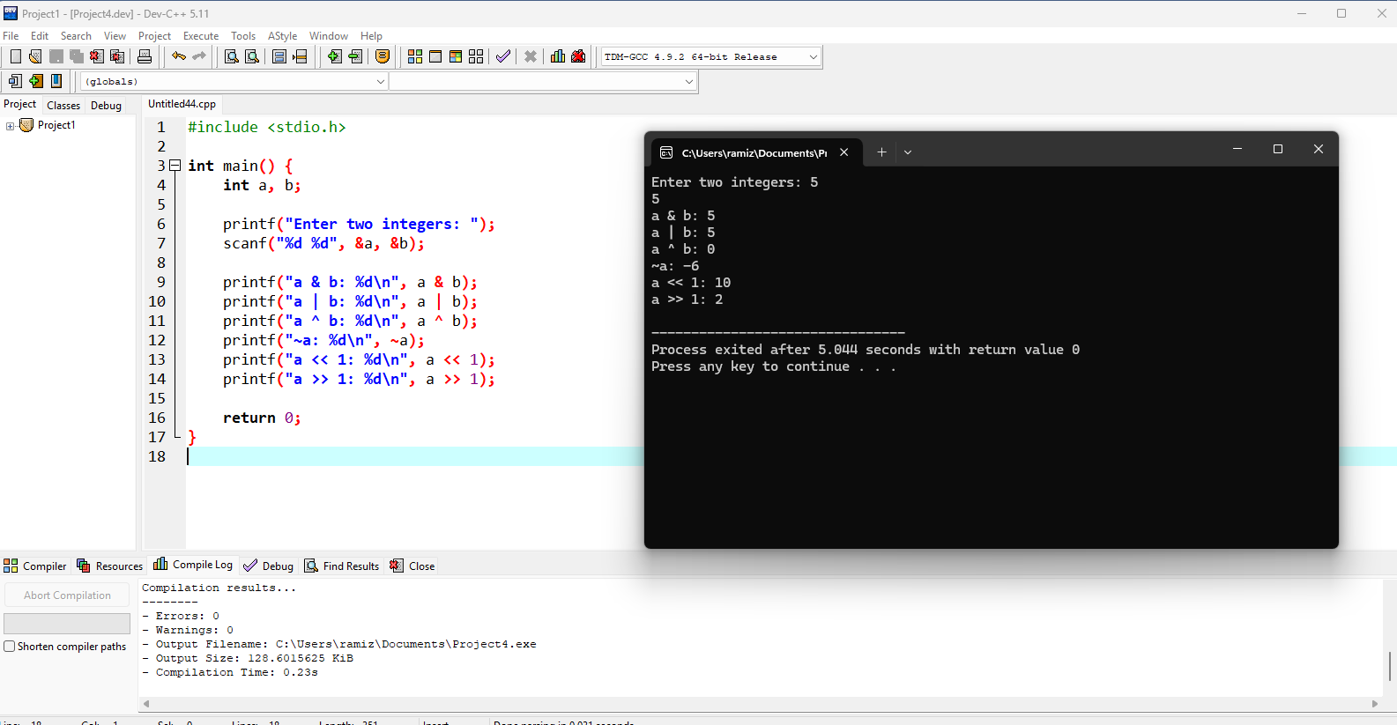

Task 10:
#include <stdio.h>

int main() {
int x, y, z;

printf("Enter three numbers: ");
scanf("%d %d %d", &x, &y, &z);

if (x >= y) {
if (x >= z) {
printf("The largest number is: %d\n", x);
} else {
printf("The largest number is: %d\n", z);
}
} else {
if (y >= z) {
printf("The largest number is: %d\n", y);
} else {
printf("The largest number is: %d\n", z);
}
}

return 0;
}

